**Attendance Management System Using Chatbot**

Project Report

Submitted in the partial fulfillment of the requirements for the award of the degree of

**Bachelor of Technology** **in**

**Department of Computer Science and Engineering**

By

**PROJECT BATCH- 265**

K V S NEERAJ -170030643

Y V SAI ASHISH - 170031428

T SAHITHI – 170031523

G DEEPIKA – 170031561

**Under the supervision of**



**Department of Computer Science and Engineering**

K L E F, Green Fields,

Vaddeswaram- 522502, Guntur (Dist.), Andhra Pradesh, India.

Nov 2020

**TABLE OF CONTENTS**

1. Declaration ……………………………………………………..3

2. Certificate ……………………………………………………...4

3. Acknowledgement ..….…………………………………………5

4. Abstract ..………………………………………………………..6

5. Introduction .….…………………………………………………7

6. History of Chatbot .….………………………………………….8

7. Literature Survey ………………………………………………11

8. Problem Statement…… ……………………………………….18

9. Methodology………… ………………………………………...18

10. Challenges……… …………………………………………….24

11. Experimental Analysis ….….…………………………………25

12. Results …………………..…………………………………….28

13. Future Scope ………………………………………………….33

14 Conclusions ………………………………………………….. 34

15 References ……………………………………………………..35

**DECLARATION**

The Project Report entitled “ATTENDANCE MANAGEMENT SYSTEM USING CHATBOT” is a record of bonafide work of K. V S NEERAJ, Y. V SAI ASHISH, T. SAHITHI, G. DEEPIKA submitted in partial fulfilment for the award of B.Tech in CSE to the K L University. The results embodied in this report have not been copied from any departments/University/Institute.

T. SAHITHI

G. DEEPIKA

K. V S NEERAJ

Y. V SAI ASHISH

**Certificate**

This is to certify that the Project Report entitled “ATTENDANCE MANAGEMENT SYSTEM USING CHATBOT” is being submitted by of K. V S NEERAJ, Y. V SAI ASHISH, T. SAHITHI, G. DEEPIKA submitted in partial fulfilment for the award of B.Tech in CSE to the K L University is a record of bonafide work carried out under our guidance and supervision. The results embodied in this report have not been copied from any other departments/ University/Institute.

Signature of the Co-Supervisor (If Available) Signature the Supervisor

Name and Designation Name and Designation

Signature of the HOD Signature of the External Examiner

**ACKNOWLEDGEMENT**

The success in this project would not have been possible but for the timely help and guidance rendered by many people. Our sincere thanks to all those who has assisted us in one way or the other for the completion of my project. Our greatest appreciation to my guide ”Dr Chayan Paul “, “Associate Professor”, Department of Computer Science and Engineering which cannot be expressed in words for his tremendous support, encouragement, and guidance for this project. We express our gratitude to Mr. V. Hari Kiran, Head of the Department for Computer Science and Engineering for providing us with adequate facilities, ways and means by which we can complete this project. We thank all the members of teaching and non-teaching staff members, and who have assisted me directly or indirectly for successful completion of this project. Finally, I sincerely thank my friends and classmates for their kind help and co-operation during our work.

T. SAHITHI (170031523)

G. DEEPIKA (170031561)

K. V S NEERAJ (170030643)

Y. V SAI ASHISH (170031428)

**Chapter 1**

**ABSTRACT**

Chat bot is defined as an artificially intelligent entity which can communicate with people. This interaction can be anything such as text based or a normal spoken conversation. Chat bots are mainly utilized for information retrieval in all kinds of domains. It can run anywhere namely the personal computers and mobile phones, but most of the time it is accessed through online. Most importantly a chat bot operates by the user asking few questions or starting a new topic of discussion. Chat Bots are the agents which have AI embedded and use NLP (Natural Language Processing) as to answer to user queries. Predefined knowledge base is used to help develop a response to the query mentioned. Similarly, we created a chat bot which can send emails, WhatsApp messages, play songs and retrieve best results for the given query from search engines like google by taking the instructions from the user in a voice-based format. The unique feature that our bot has got to offer is the “Attendance Management System”, teachers and working organizations do not need to take attendance manually because we enabled this through the means of facial recognition. All the students or employees need to do is get in front of the bot and take images. Images and data of the person are stored and attendance is provided.

**Chapter 2**

**INTRODUCTION**

A chatbot is frequently quoted as one of the most leading and promising mediums of interaction between people and machines. Although, while seeing from an industrial point of view, a chatbot only represents the natural evolution of a query answering system influencing Natural Language Processing. Devising responses to queries in natural dialect is one of the most classic examples of NLP in various domains and user applications.

The capability to understand the user’s request and retrieve data and relevant things related to the user’s request is very important. Chatbot applications include interactions between humans and different services from different domains, also improving the customer experience. Also they provide companies many new opportunities to enhance the customers’ engagement procedure and viable efficiency by decreasing the high costs of customer service.  
There are many domains achieving huge profits from installing chatbots. Some of these top domains include are retail, e-commerce, entertainment, hospitality, finance, health care sector, news, government and many more.

In this project, we are designing a chatbot with special features that include,  
-Giving optimal solution for any requirement from Google: On asking the bot for a specific query, it will provide us with the best and succinct result from Google. For instance, queries can be anything from “the best restaurant in a locality”, “comedy movies to watch” or even

The president of India”

-Sending e-mails to a particular recipient: The bot can compose and send e-mails on mentioning the email id of the recipient.

-Sending messages through whatsapp: To send a whatsapp message we need to login to our whatsapp web by scanning the code and then send required message by mentioning the name of the contact we want to send it to.

-Playing music: Our bot plays any type of music according to the interest of the user.  
-Opening any webpage in browser: As we know, when we directly Google anything, we get an abundant amount of results. These results may or may not be desirable. So the bot on requesting a webpage provides you with one of the best and efficient webpage from the lot.  
-Opening a file present in our local system: We can choose from the drives present in our PC and ask for the file required and that file will be retrieved.

-Attendance Management System: Main feature of our bot is to take attendance based on facial recognition. We just need to ask the bot, "Please take the attendance of the particular person" and then it will detect the face and check whether the person’s details are present in the database or not. If they're present, it will just update the attendance. However, if the person’s details are not present, it will store the details of the person and then provide the attendance.

**Chapter 3**

**HISTORY OF CHATBOT**

The first Chatbot ever was made By MIT Professor Joseph Weizenbaum in the year of 1966.It was called ELIZA. Joseph had made this chatbot with the methodologies of pattern-matching and substitution to start or continue the conversation/discussion. ELIZA works by passing the words that the clients enters and matches them with a list of enlisted scripted records. The script of Eliza had created a noteworthy effect on NLP and Artificial Intelligence by protruding a variants of copies on it within academics. Due to the increase of trust and interest in the ELIZA the users started to converse with ELIZA with most profound and significant ideas whereas the creator has just made it to imitate a normal human conversation. Due to this the chatbot makers have built their chatbots making ELIZA as an example and improving for more human interactions and passing a Turing test has made a basic qualification for the chatbots which tests the chatbot’s conversational ability against a board consisting humans.

In the following years many bots were created for various purposes with different type of applications which are mentioned in the below table.

|  |  |  |  |  |  |
| --- | --- | --- | --- | --- | --- |
| **S.no** | **Name** | **Created by** | **Year** | **Algorithms/Working Methodology** | **Functionality** |
| 1 | Parry | Kenneth Colby | 1972 | Natural Language Processing | It resembles the thinking of an Individual (A patient) with schizophrenia. It works with a set of complicated assumptions and attributions and emotional responses which are stimulated by a varying verbal input given by user. |
| 2 | Jabberwacky | Rollo Carpenter | 1988 | Contextual pattern matching | It is created to stimulate or trigger an entertaining way of basic human interaction and also to keep people company |
| 3 | Dr. Sbaitso | Creative labs for MS-Dos | 1992 | Articulatory Synthesis, Concatenative Synthesis and Voice Cloning with Self | It is one of the first efforts of incorporating artificial intelligence and also the first full voice operated chat program. This program would converse with user taking the role of a psychologist. |
| 4 | A.L.I.C.E | Richard Wallace | 1995 | Heuristic Pattern Matching and AIML (XML Schema) | This chatbot simulates chatting with a real. Alice is a designed as young-looking woman with human years, tells user his age, hobbies and some astounding facts along with answering user’s query except that it didn’t have a particular purpose. |
| 5 | Smarter Child | Robert Hoffer | 2001 | Instant Messaging using Artificial Intelligence | It is herald of “Siri” in many ways. It has the strength to have or carry out the fun conversations with its users and also have an quick data access to other servers |
| 6 | Siri | Apple | 2010 | Natural Language UI | It is one of it’s first kind in AI bots and Personal Assistants. Siri will respond to a text, audio, image, and video transferred to it by the user. |
| 7 | Google Now | Google | 2012 | Predictive Search,  It recognizes repeated actions that a user performs on the device to display more relevant information to the user | It is brought as competition to “Siri”. It is designed to proactively search for the information user may need in the form of informational Cards |
| 8 | Cortona | Microsoft | 2014 | Voice recognition, Natural language Understanding | This program is mainly used to set remainders, send emails texts, play games and to chit-chat and also to find files based on voice or text command and search in web for the user queries |
| 9 | Alexa | Amazon | 2014 | Voice Recognition | A complete voice- based application can be used to play music, search web and many more daily-life activities (set alarms, get news and weather reports etc) |

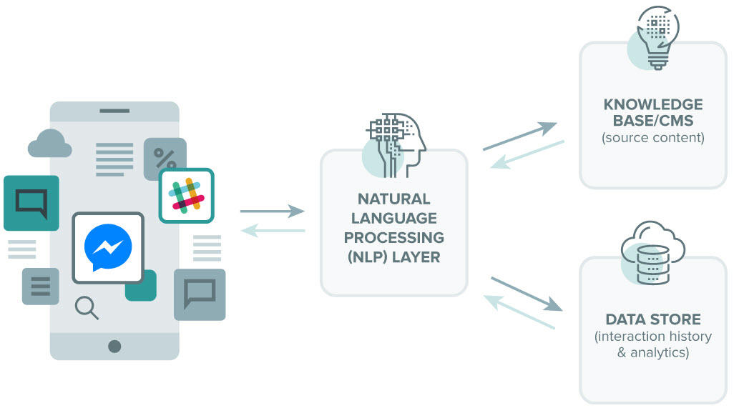

Fig 3.1-Conceptual Representation of a Chatbot (source: https://www.wordstream.com/blog/ws/2017/10/04/chatbots)

**LITERATURE SURVEY**

|  |  |  |  |  |  |
| --- | --- | --- | --- | --- | --- |
| **S.No** | **Title of the**  **Paper** | **Author** | **Objective** | **Methodology**  **/Algorithms** | **Results** |
| 1. | Enhancing College Chat Bot Assistant with the help of Richer Human Computer Interaction and Speech Recognition | Sangeeta Kumari,Zaid Naikwadi,  Akshay Akole,  Purushottam Darshankar | The goal of this framework is to give a stage to understudy and guardians to ask inquiries and clear questions through basic English language instant messages or sound orders. | Natural Language Processing  (NLP) ,Natural Language  Understanding (NLU)  ,Structured relational database or  XML ,Mongo DB,  (REST API) | Users feedback to the reply received to their query is taken.  This data is stored in the database which can be reviewed by the administrator |
| 2. | INTELLIGENT WEB-BASED VOICE CHAT BOT | S. J. du Preez,  M. Lall,  S. Sinha | The goal is to design and develop of an intelligent voice recognition chat bot. By presenting an artificial brain, the web-based bot produces customized user responses, adjusted to the desired character. | AI, XML,  JAVA, AIML, ALICE,HTML | The blend of voice input and voice output allows for a easier encounter which permits a client to run on numerous sorts of stages. Since the customer is internet based the subsequent stage would be portable or even thin customer frameworks. |
| 3. | Chat Bot using API: Human to Machine Conversation | Sunil Punjabi,  Vignesh Sethuram,  Vignesh Ramachandran,  Ronit Boddu,Shivshankar Ravi | Utilizing this chatbot our assignment of visiting various website pages to complete required railway requests can be spared with numerous user friendly applications. | Dialog flow,  java, postman,  Server, Railway AP | Application based framework which gave to get suitable reaction dependent on the contribution of the user. The framework will help the clients by giving fitting reactions dependent on inquiries. |
| 4. | AlzBot: An Intelligent Chatbot for Alzheimer Patients | Khilti Dedhia , Viren Dattani, Akash Dharod , Akanksha Chhatry , Deepti Nikumbh | Fundamental aim of the chatbot is to help the Alzheimer patients determined to have early and moderate level. Alzheimer's disease is the most well-known reason of dementia —a nonstop decrease in reasoning, conduct and social aptitudes that disturbs an individual's capacity to work autonomously. | AIML,NLP Technology, Conversation System, RNN encoder-decoder | Assist Alzheimer patients to help and guide them in their day by day schedule, assist them with keeping up their timetable, remind them to take prescriptions. It will alarm the crisis contacts and the patient's PCP during crises and help them track the patient utilizing GPS framework. |
| 5. | Chatbots and Virtual Assistant in Indian Banks | Netra Pal Singh Devender Singh | Indian banks both public and private area has dispatched chatbots/menial helpers to diminish the operational expenses and increment the consumer loyalty by giving the financial administrations through these menial helpers. | IOT , AI , Mobile Banking,  Internet banking, Data Science | All general queries, balance check, ordering cheques book, mini statements, recent transactions can be carried out by chatbots. |
| 6. | Contract Statements Knowledge Service for Chatbots | Boris Ruf, Matteo Sammarco, Marcin Detyniecki. | To design conversational specialists that are fit for handling of more intricate inquiries on legally binding conditions, formalizing contract proclamations in a machine discernible way is pivotal. | AI , IOT , DS | A top-down information designing methodology which improves the abilities of conversational specialists. Empowers more intelligent, unique reactions. |
| 7. | Enriching Conversation Context in Retrieval-based Chatbots | Amir Vakili and Azadeh Shakery | Work on recovery based chatbots, as most grouping pair coordinating assignments, can be isolated into Cross-encoders that perform word coordinating over the pair, and Bi-encoders that encode the pair independently. | AI , DS, Natural Language   Understanding (NLU), | Shows sentence portrayals made with transformer designs .Convey enough data to be utilized for information improvement in recovery based chatbots. |
| 8. | #MeTooMaastricht: Building a chatbot to assist survivors of sexual harassment | Tobias Bauer , Emre Devrim, Misha Glazunov, William Lopez Jaramillo, Balaganesh Mohan, and Gerasimos Spanakis | To extricate spatio-transient subject data to appropriately help the survivor by guiding them to suitable organizations that can offer them help and increment the mental health. | NLP (Text recognition, classification), Named Entity Recognition. | Results gave an over 80% exactness for recognizable proof of provocation type. Starting consequences of this work are truly reassuring into ways that overcomers of badgering can be helped by methods for information science. |
| 9. | Say What I Want: Towards the Dark Side of Neural Dialogue Models | Haochen Liu ,Tyler Derr, Zitao Liu , Jiliang Tang | Investigate whether we can craft inputs that lead a well-trained black-box neural dialogue model to generate targeted outputs. | NLP (Reverse Dialogue Generator ), Text classification. | Finds an input which leads to an output whose similarity to the targeted one is above a preset threshold, we say the manipulation is successful. |
| 10. | Personalizing Dialogue Agents: I have a dog, do you have pets too? | Saizheng Zhang, Emily Dinan, Jack Urbanek, Arthur Szlam, Douwe Kiela, Jason Weston | Making chit-chat models additionally captivating and reliable by means of molding on industrious and conspicuous profile data. | AI , DS,  Natural Language  Understanding (NLU), | Testing of different pattern models on this dataset shows that models that approach their own personas are perceived as more steady by annotators. |
| 11. | Dialogue Learning with Human Teaching and Feedback in End-to-End Trainable Task-Oriented Dialogue Systems. | Bing Liu, Gokhan Tur, Dilek Hakkani-Tur, Pararth Shah, Larry Heck | To gathers new dailouge tests through cooperation with clients, for example at the point when the specialist commits errors, the framework requests that clients right these slip-ups and show the normal activities for the specialist to make. | AI , IOT , DS | Proposes a hybrid impersonation and reinforcement learning strategy, where the specialisis firstly trained in a supervised manner from dialogue corpora, and then, continuously improves its performance by learning from users |
| 12. | Sounding Board: A User-Centric and Content-Driven Social Chatbot | Hao Fang, Hao Cheng, Maarten Sap, Elizabeth Clark, Ari Holtzman, Yejin Choi, Noah A. Smith, Mari Ostendorf | A great social chatbot can help the organization increment client reliability and commitment. | Natural language understanding (NLU),  Dialogue manager (DM) | Analyzing how extraordinary character types collaborate with the framework and indicating that clients who are more extraverted, pleasant, or open to encounter will in general rate the socialbot higher.. |
| 13. | Training Millions of Personalized Dialogue Agents | Pierre-Emmanuel Mazaré, Samuel Humeau, Martin Raison, Antoine Bordes | * Customized exchange specialists which are probably going to create more cognizant reactions and get higher client commitment | AI , DS,Natural Language   Understanding (NLU), | Training using personas improves the performance of end-to-end systems. |
| 14. | Open Data Chatbot | Sophia Keyner,Vadim Savenkov, and Svitlana Vakulenko | Open Data makes a perfect use case for the integration of the spatial linked data source, as it was previously shown to heavily rely on the geographic dimensions. | Entity Recognition, Intent Classification, Integrating state-of-art parsing, semantic technologies and conversational search. | An Implementation of a chatbot that provides conversational search interface to an Open Data repository utilizing geo-entity annotations. |
| 15. | InstructableCrowd: Creating IF-THEN Rules for Smartphones via Conversations with the Crowd | Ting-Hao K. Huang, Amos AZzaria,  Oscar J. Romero, Jeffery P. Bigham, | InstructableCrowd, a crowd fueled framework that permits clients to program their gadgets through discussion . The client verbally communicates an issue to the framework, wherein a gathering of group laborers by and large react and program important multi-part IF-THEN principles to help the client. | AI , IOT , DS | This outcome proposes that InstructableCrowd gives a simpler method to form applications for the clients who experience issues making complex guidelines physically on their telephones. |

* In Kumari et. el, [1] chat bot responds in conversation just like how a human interact with each other. It works as a virtual assistant and its accuracy is determined by finding correlation between user's queries and answers provided by chat bots. Implemented Chat bot provides two modes like text mode and audio mode for better user experience.
* In S.J. et. el, [2] a black box approach is used, by controlling the communication structure, to and from the Web-service, the Web-service allows all types of clients to communicate to the server from any platform. The service provided is accessible through a generated interface which allows for seamless XML processing; whereby the extensibility improves the lifespan of such a service.
* In Punjabi et. el, [3] the Chatbot can be integrated with various platforms such as facebook, Google assistant, viber etc, So , we can say that, using this chatbot our task of visiting multiple web pages to complete required railway requests can be saved with multiple user-friendly applications.
* In Dhedia et. el, [4] they designed a self-learning chatbot which will remember the information given by the patient and also learn from past mistakes. It will also contact the emergency near-dear ones/doctor when he patient doesn't respond for quite a long time excluding his/her sleep hour.
* In Pal Singh et. el, [5] Chatbots & Virtual Assistant can be embedded and used through any major messaging applications. Chatbots enable personalized services, reduction in waiting time for users, uninterrupted customer support, and a feedback channel to a large number of customers, and guaranteeing consumer satisfaction.
* In Ruf et. el, [6] after identifying the most relevant contract statements, we model their underlying rules in a novel knowledge engineering method. A user-friendly tool we developed for this purpose allows to do so easily and at scale. Then, we expose the statements as service so they can get smoothly integrated in any chatbot framework.
* In Vakili et. el, [7] development of a sequence matching architecture that %takes into account contexts in the training dataset at inference time , utilizes the entire training set as a makeshift knowledge-base during inference. They performed detailed experiments demonstrating that this architecture can be used to further improve Bi-encoders performance while still maintaining a relatively high inference speed.
* In Bauer et. el, [8] they broke down the problem into three data science/machine learning components: harassment type identification (treated as a classification problem), spatio-temporal information extraction (treated as Named Entity Recognition problem) and dialogue with the users (treated as a slot-filling based chatbot). they were able to achieve a success rate of more than 98% for the identification of a harassment-or-not case and around 80% for the specific type harassment identification. Locations and dates were identified with more than 90% accuracy and time occurrences prove more challenging with almost 80%.
* In Liu et. el, [9] Experiments conducted on a representative neural dialogue model show that their proposed model is able to discover such desired inputs in a considerable portion of cases. Overall, their work reveals this weakness of neural dialogue models and may prompt further researches of developing corresponding solutions to avoid it.
* In Zhang et. el, [10] they collected data and train models to (i) condition on their given profile information; and (ii) information about the person they are talking to, resulting in improved dialogues, as measured by next utterance prediction. Since (ii) is initially unknown our model is trained to engage its partner with personal topics, and we show the resulting dialogue can be used to predict profile information about the interlocutors.

**Chapter 4**

**PROBLEM STATEMENT**

Creating a fully efficient Chat Bot that includes features like sending an electronic mail and a Whatsapp message to a particular recipient, playing songs of choice, giving an optimal result of user query from Google and more importantly make taking attendance easier. This task includes taking pictures of the candidate and providing attendance through facial recognition.

**METHODOLOGY:**

**4.1 Web Searching:** For all the user queries that need to search the web we have used Wolfram Alpha API

.Wolfram alpha is a Computational Knowledge engine also known as semantic search engine. Unlike the conventional search engine this Wolfram alpha provides us a complete list and tables to provide users with specific answers to their queries.

Some of the features this search engine provides briefly are:-

* Calculations including algebra matrices and has a command in trigonometry and also number theories. In addition to these it also can perform calculations on chemical formulas and can perform operations on finance and relational computations.
* Information on nutritional value of food can also be obtained by using this search engine
* Conversion of units and time differences
* Image analysis
* File Analysis
* Comparisons between two same entities and many more

Wolfram Alpha web services API which is a web-based API allowing the computational and presentation capabilities of Wolfram Alpha to be integrated into web and different other types of applications. Wolfram Alpha is an API which can compute expert level answers using Wolfram’s algorithms, AI technology and Knowledgebase which is made possible by Wolfram Language. This is used in the application by using Wolfram alpha package and using a client id obtaining from the official wolfram alpha website.

The operations needed to perform web searching by using Wolfram-alpha API is

* Register the Client id
* Create a WolframAlpha Client object with Client id
* Give the query along by using object

We used this package to perform different computations on the query and get the optimized result.

**4.2 Sending Mails:** For this functionality we have used smtplib library.

Simple Mail Transfer Protocol is a protocol used to send e-mails and also routing of e-mails between the mail servers. “smtplib1” module is used in the application for sending mails by having an SMTP client session object. This object needs different parameters they are :

* Host : The domain name or IP address of the host running our SMTP server
* Port : The port where the SMTP server is Listening
* Local Host-name : The local host name of the machine where the SMTP server is running

To send mail we have to use send mail instance along with different Session object which is basically mailing the message.

The parameters of the send mail instance are :

* The sender : the e-mail address of the person mailing
* The receivers : The e-mail addresses list for whom the mail is to be sent
* The message : the message which we have to send the receivers in the specified format

Different types of e-mails that can be sent using smtplib are:

* A Plain text e-mail
* A HTML e-mail
* E-mail with Attachments
* Multiple E-mails at a time

**4.3 Sending WHATSAPP Messages:** For this functionality selenium package and web driver tool is used

Selenium is an open-source testing framework used to validate web applications. Primarily selenium is developed by Jason Huggings in 2004 and web driver is created by Simon Stewart which is the first cross-platform testing framework that could control the browser from the OS level. Selenium web driver can be used to automate web application testing and verifying

Web driver is used to open the web application of Whatsapp after the web application is opened and we have scanned the QR code. The following operations are performed using the web driver object

* Finding the search box
* Clicking the search box
* Finding the required contact
* Clicking the required contact
* Finding the message text box
* Clicking the message text box
* After the message is sent web driver will kill the instance of the web-driver

**4.4 OS Accessing:** For this functionality OS module in python.

OS module provides functions for interacting with the operating system. This module comes under Pythons standard utility modules.

The OS module provides with an access method to test path of the file and also the Permissions of the file. It also used to test whether the invoking user has specified access to the path. After checking the access we can get to read or write the file based on the permissions

Some of the functions in OS module include

* os.name – gives the name of the operating system
* os.getcwd()- return the current working directory
* os.error – used to raise a error if the given file name or path is invalid
* os.open() -used to open a file
* os.close()-used to close a file / file descriptor
* os.rename()- used to rename a file
* os.chdir() – used to change the directory
* os.environ()- used to return all the directories of all the user user environment variables
* os.rmdir()- used to remove a directory
* os.lisdr() – used to list all the directories in the current file

Similarly there are many more functions which can be used by OS module.

By using this OS module we can use it to play music also by giving the path to music file.

In our application this module is used for the following set of operations:

* Opening a file
* Closing a file
* Playing System
* Shutdown System
* Restarting the System

**4.5 Emotion Detection:**

For this Functionality we have used Keras and OpenCV modules.

Keras is an open source neural network library François Chollet in the view of it to be modular, fast and easy to use. It is written in Python. It runs on top of TensorFlow or Theano. It is high level API Wrapper and uses another library called “Backend” to perform low-level computations. Keras performs the following Operations:

* Handles the way we make our models
* Handles Defining Layers
* Set up multiple input output models
* Compiles the model with loss functions
* Compiles the Functions with Optimizer functions
* Trains Process with fit function

In our application we used Keras for converting image into numpy array which is then used to perform prediction on the image for detection of emotion.

OpenCV is a open source library for computer vision, machine-learning and image-processing and also plays a major role real-time operations in present day systems.

By using this library one can process different types of images, videos, and also handwriting and faces of humans. It can also be integrated with some other libraries to perform different operations.

Applications of OpenCV: There are lot of applications which can be performed by using OpenCV some of them are

* Face Recognition
* Automated Inspection and Surveillance
* Count of number of people in crowded places
* Measure of number of vehicles on highways and their speeds
* Interactive art Installations
* Anamoly detection in the manufacturing process
* Street view image Stitching
* Video/Image search and retrieval
* Robot and Driver less car navigation and Control
* Object recognition
* Medical image Analysis
* Movies- 3D structure from motion
* TV Channels advertisement recognition

Functionalities of OpenCV:

* Image Processing
* Video Processing
* I/O Processing
* Object recognition
* Feature recognition
* Geometry based monocular or stereo computer vision
* Computational photography
* Machine learning &clustering
* CUDA acceleration

We have used this module to classify the image and process the image and determine the emotion.

**4.6 Attendance Management:** For this Functionality we have used OpenCV, Tkinter and pandas modules.

OpenCV:

OpenCV is an open source library for computer vision, machine-learning and image-processing and also plays a major role real-time operations in present day systems.

By using this library one can process different types of images, videos, and also handwriting and faces of humans. It can also be integrated with some other libraries to perform different operations.

In our application this module is used for the following set of operations:

* Training images
* Taking images and matching them with stored ones in the data and giving the attendance to the person

**4.7 Tkinter**

It is a standard GUI library for Python. By making use of this library one can create GUI applications in a fast and easy way in python. There are different types of widgets that comes with Tkinter. Some of them includes

* Button
* Canvas
* Checkbutton
* Entry
* Frame
* Label
* Listbox
* MenuButton
* Menu
* Message
* RadioButton
* Scale
* ScrollBar
* Text
* Toplevel

The Standard attributes of Tkinter library include:

* Dimensions
* Colors
* Fonts
* Anchors
* Relief Styles
* Bitmaps
* Cursors

In our application this module is used for the following set of operations:

* We used the function Tk() which is used to create a root window which is a main application window that consists of title bar and borders in our programs
* We used the function mainloop() which is used to start the event handling with events received from the window system and sent to the application widgets
* To provide caption to the other widgets and contain the image
* To display a message after accepting the user given values
* To display buttons on the page

**4.8 Pandas:**

The Pandas package is one of the main package and acts as a backbone of the data projects for the main purpose of data manipulative analysis. We can perform operations on data in the ways like cleaning, transforming and analysis using pandas. It is used by combining with

Other libraries in the tool kit collection of data science. It is used for statistical analysis in Sci-Py, Plotting functions from Matplotlib and also machine learning algorithms in Scikit-learn.

Features of Pandas:

* Alignment and Indexing
* Handling Missing data
* Cleaning up data
* Input and Output tools
* Multiple file format supported
* Merging and Running of Data sets
* A lot of Time-series functions
* Optimized Performance

Major Applications of Pandas are:

* Economics
* Analytics
* Stock Prediction
* Natural Language Processing
* Big Data
* Recommendation Systems and so on

In our application this module is used for the following set of operations:

* It is used to read CSV file
* To convert the data into list

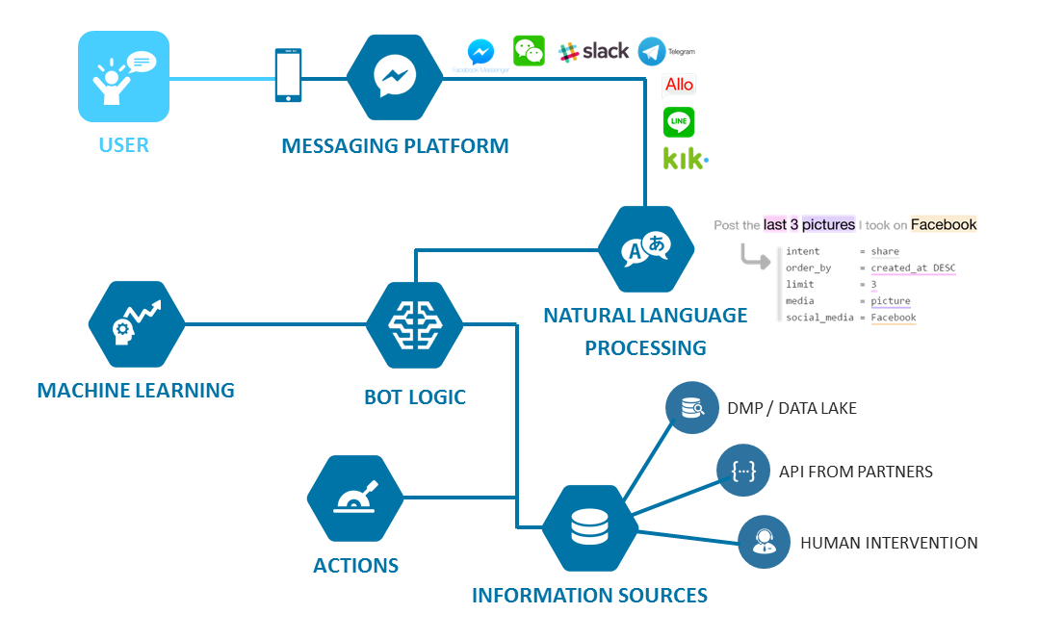

Fig 4.1-Step by Step process of Working Chatbot (source: https://www.cosoit.com/evolution-of-chat-bots-from-NLP-to-NLU)

**Chapter 5**

**CHALLENGES**

* Our main aim was to make a chatbot which offers genuine value to the users. In this way, we chose to add different features like taking attendance, accessing search engine, sending mails through voice control, accessing files etc. With the increase in features, the complexity of the code increased which required a considerable amount of expertise.
* Initial challenge we confronted was to pick between voice actuated chatbots and text based chatbots .Yet considering the comfort of the users we chose to construct a voice enacted chatbot.
* Another hurdle we confronted was storing an immense measure of information. There were huge number or pictures to be stored as we utilized sixty-one images of every understudy for face recognition. This task needed a lot of monitoring and management.
* Training the pictures and applying appropriate face recognition algorithms to compare faces with the images from the database was difficult. We tried various algorithms to find which suits best for our project which took a lot of efforts and time.
* Adding name and Id number to every student’s picture was another immense hindrance that we had experienced as it was hard to comprehend if the particular information is accurately being recognized or not. We tried verifying, using several student entries to ensure that there is no uncertainty.
* One obstacle even in the wake of guaranteeing the effective development of a chatbot was to know when a human requires to takeover. There are consistently a couple of situations where a chatbot can't resolve the user query. Along these lines, finding such situations where human contribution was required was fundamental for the improvement of our project.
* There were circumstances where a minor error in the program prompted crashing of the chatbot. This happened commonly while endeavouring to add different features to the bot. Amending these sort of errors was extremely testing.
* The fundamental necessity is to have a strong security for the chatbot. Enabling the chatbot to access the system folders, internet, taking security measures as well, was an obstacle which required a ton of information on framework security.
* Text recognition, text translation, acquiring optimal results from search engines are various other challenges that we faced while implementing the chatbot.
* It was really difficult to perform mail simulation as Gmail doesn't support less secure apps like python IDLE etc. We tried to use different modules for this operation to be functional. Smtplib module helped to perform this operation without causing any trouble in the servers and also it was easy to access.

**Chapter 6**

**EXPERIMENTAL ANALYSIS**

**6.1 CONVERSATIONAL MATURITY:**

A chat bot operations is not only working functionality and interacting conversationally, it has a specific function called Natural Language Processing (NLP) which helps in understanding the user queries in multiple languages. It also recognizes the context of the question and provides the best response, also displays different options of the same context to get grip on the user’s interests. The communication with the chat bot can be through voice or linear and performs advanced computations to seek out information.

**6.2 VOICE TRANSFERENCE:**

The main work of a chat bot is to receive the information from user thorough voice command and show case its capabilities. PyAudio can be used as a main source of the chat bot which plays and records audio on variety platforms. PyAudio is a cross-platform, open-source, and simple interface to deal with audio. Microphone acts as an essential input device where PyAudio module activates it so that user can conveniently interact with the chat bot.

Features of Chat Bot:

**6.3 MAIL BOX SIMULATION:**

Sending and Receiving emails can also be performed smoothly with a chatbot. Automation of the emails helps in reducing manual work and also performs actions without causing any ambiguity. Simple Mail Transfer Protocol (SMTP) is a communication protocol for electronic transmission. Smtplib is the module that supports the chatbot in the transmission of the emails. The content of the email and receiver’s information can be disclosed with the chatbot with voice commands instead of typing.

**6.4 WHATSAPP CIRCULATION:**

Whatsapp is always the best interface for communicating with closed ones. Chatbot also makes this process simpler. Selenium is an open-source web-based automation tool. It uses this module and helps to transfer the messages to another user any number of times.

**6.5 ACCESING OS:**

Sometimes it becomes difficult for the user to search for a particular file's location and access it. It requires a lot of manual work and needs to dig deeper. This chatbot will be able to locate any file and retrieve it for the user and it would take less time compared with searching every folder. It also has access to the user's playlist so when the user asks for any song or movie it instantly plays it.

**6.6 SEARCH ENGINE:**

When the chatbot is been asked with a query it gives an optimal result to user which will be very helpful at that point. It parses the query into pieces and searches for each and every word and gets the solution for it. Wolframalpha is the unique engine for computing answers and providing knowledge. It is an API which acts as a bridge between the chatbot and search engines and performs numerous computations.

**Attendance Management System:**

Irrespective to the features mentioned above, Attendance Management is the main backbone of the entire project and with the help of chatbot the organization will be able to record every student’s attendance without any confusion, errors and human involvement. The working of this feature is as follows:

**6.7 IMPORTING IMAGES:**

If the student is new to particular session or organization, the chatbot notes the details of the student and captures the images of students face. It takes 61 images of the particular student in different poses and all are stored in the database.

**6.8 FACE RECOGNITION:**

The training of the images is done in such a way that it takes the measurement of the face captured in those images and stores the values of these predicted measures. And if the student appears again it checks with the predicted measures stored in the xml file and after running the course it displays the information of the student instantly.

**6.9 MARKING ATTENDANCE**:

Once the prediction of face is completed with help of the measurements stored, it takes the attendance for that particular student in an excel sheet storing the details of the student as well as the date and time of when the attendance is been taken. It segregates the attendance by the date and time so that it doesn’t gets mixed up.

**Chapter 7**

**RESULTS**

* 1. **Sending Message through Whatsapp**

Fig 7.1.1- Messages sent to the User through Chatbot

Chatbot Interacting with User for sending messages through Whatsapp.

Fig 7.1.2- Conversations of User and Chatbot for sending message through Whatsapp

On asking the bot “send a message”, it will ask for the recipient name to send message to. After specifying the name, it will for the message content. Then a random button is to be pressed for scanning the whatsapp QR code and message will be sent successfully.

**7.2** **Sending Message via email**

Fig 7.2.1- Chatbot sent email to specified Recipient

**7.3 Attendance Management System**

If the user wants to take attendance for an employee, student or any person in particular, he can ask the bot and it will direct to attendance page as follows,

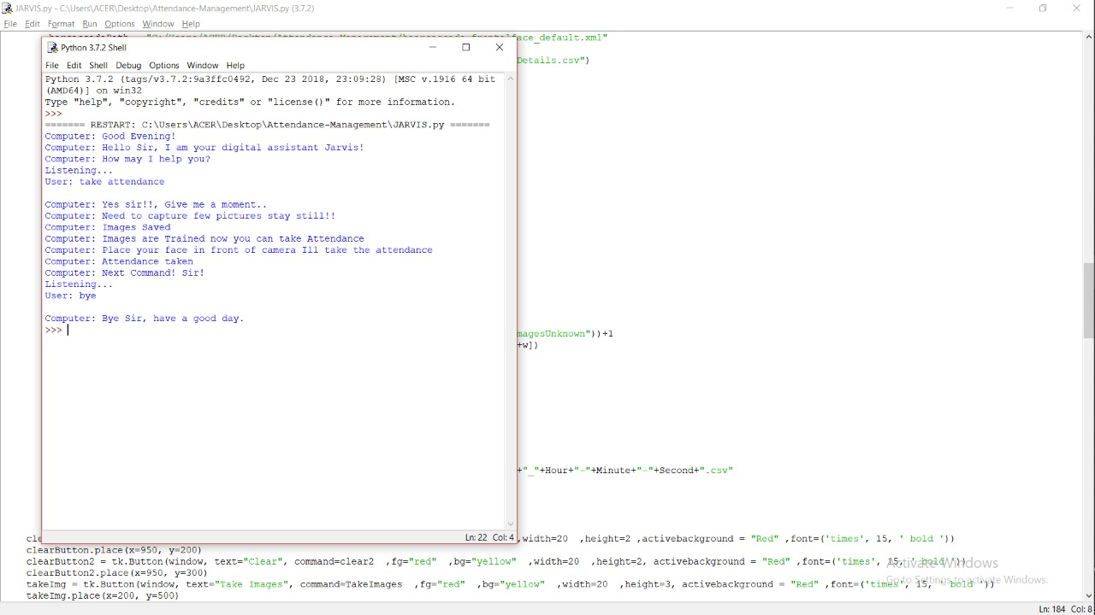

Fig 7.3.1- Steps by Step process displayed by Chatbot while taking Attendance

Fig 7.3.2- Webpage outlook for considering Attendance

Fig 7.3.3- Entering details of respective candidate

Candidates name and ID are to be entered as shown above to check wether that persons data is already existing.”Task Images” can be clicked in order to take images of the person in case his details are not present. “Train Images” and “Track Images” must be clicked simultaneously after that.

Fig 7.3.4- Chatbot performing Face Recognition on the respective student

Once the images are trained, the details are saved as shown below,

Fig 7.3.5- Chatbot updating the status of Attendance

These details will simultaneously be saved into an excel sheet as shown below,

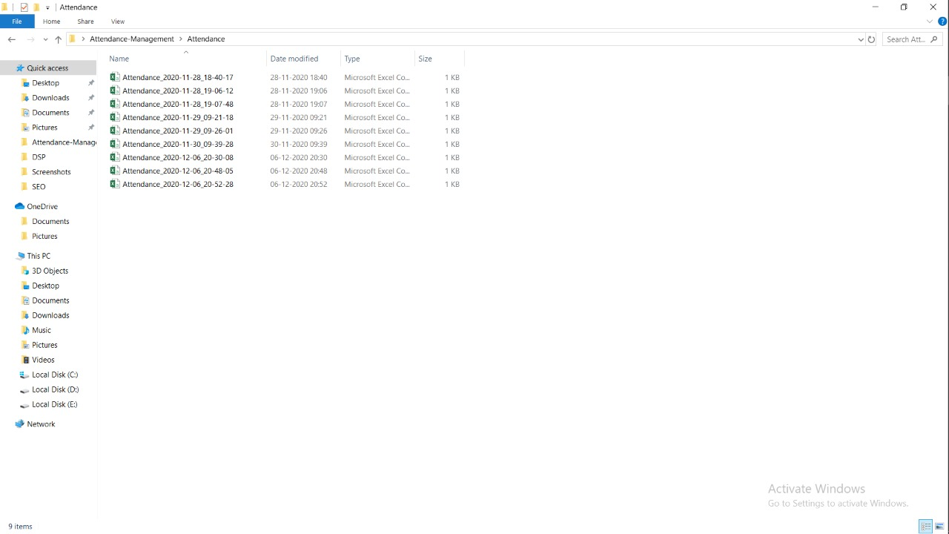

Fig 7.3.6- List of Attended Students segregated with date and time



Fig 7.3.7- Chatbot storing student details and time attended

If the details are present in the excel sheet, it means that the attendance has been considered.

**Chapter 8**

**FUTURE SCOPE**

In the coming years all the people in different domains needs to be paid attention. In person a Individual cannot be hired for the sole purpose of attending the user’s queries. Thus an automation is required. By taking this consideration a chatbot can be created, trained and implemented as part of the work flow / work system to do the work of the individual. Chatbot can be used in number of different domains that needs a conversation with client on a daily basis. A chatbot can be configured / Customized and can be improved by suggesting a solution for every situation that has a probability of user encountering it. The bot we developed can be used and improved mainly in the fields of emotion detection and Attendance Management.

**8.1 EMOTION DETECTION**

It is possible to implement an app using this framework that can detect facial expression to elevate the mood of a user and helping them by giving advices and consoling them and also being helpful like a family member. If the accuracy of the emotion detection increases and can detect from the slight change of expressions in faces which will be a major advantage of the applications for facial emotion recognition.

**8.2 ATTENDANCE MANAGEMENT**

It is possible to implement this framework in different institutions or organizations where the In-time and out-time is to be stored and can be used to store clock ins and clock outs of an individual and present them clearly in a excel sheet and also this framework with a little modifications can be used for Absence Management where the individual leaves can also be stored which will be easy for an institution or organization to consolidate the data of the individual

**Chapter 9**

**CONCLUSION**

Chatbots with artificial intelligence are dramatically changing businesses. There is a wide range of chatbot building platforms that are available for various enterprises, such as e-commerce, retail, banking, leisure, travel, healthcare, and so on. It takes practice and a deeper understanding of underlying concepts to get the design right and build bots that give users a great experience. The user should be able to get the job done by having a conversation with the chatbot without having to think too much and with a smile on their face. The Attendance feature added to our chatbot will help the different organizations to consider the attendance of every student and recording their information without any human stress and any ambiguity. Also, we will be developing this chatbot into a personal assistant that acts as a counselor and gives people advice. In this way, chatbots reach out to a large audience and become more effective than humans.

# **REFERENCES**

|  |  |
| --- | --- |
| [1] | S. Kumari, Z. Naikwadi, A. Akole and P. Darshankar, "Enhancing College Chatbot Assistant with the help of Richer Human Computer Interaction and Speech Recognition," *IEEE,* pp. 7-10, 2020. |
| [2] | d. P. S.J., L. M. and S. S., "Intelligent Web-based Voice Chatbot," *IEEE,* p. 6, 2009. |
| [3] | S. Punjabi, V. Sethuram, V. Ramachandran, R. Boddu and R. Shivshankar, "Chatbot using API: Human to Machine Conversation," *IEEE,* p. 5, 2019. |
| [4] | K. Dedhia, V. Dattani, A. Dharod, A. Chhatry and D. Nikumbh, "Alzbot: Intelligent Chatbot for Alzheimer Patients," *IJRESM,* pp. 3-4, 2019. |
| [5] | N. P. Singh and D. Singh, "Chatbots and Virtual Assistant in Indian Banks," *Industrija,* p. 27, 2019. |
| [6] | B. Ruf, M. Sammarco and M. Detyniecki, "Contract Knowledge Service for Chatbots," *arXiv,* p. 6, 2019. |
| [7] | A. Vakili and A. Shakery, "Enriching Conversation Context in Retrieval-based Chatbots," *arXiv,* p. 8, 2019. |
| [8] | T. Bauer, E. Devrim, M. Glazunov, W. Lopez, M. Jaramillo and G. Spanakis, "#MeTooMaastricht: Building a chatbot to assist survivors of Sexual Harassment," *arXiv,* p. 19, 2019. |
| [9] | L. Haochen, T. Derr, L. Zitao and J. Tang, "Say What I Want: Towards the Dark Side of Neutral Dialogue Models," *arXiv,* p. 11, 2019. |
| [10] | S. Zhang, E. Dinan, J. Urbanek, A. Szlam, D. Kiela and J. Weston, "Personalizing Dialogue Agents: I have a dog, do you have pets too?," *arXiv,* p. 5, 2018. |
| [11] | "Chatbot: What is a Chatbot? Why are Chatbots Important?," 17 March 2020. [Online]. Available: https://www.expert.ai/blog/chatbot/. [Accessed 29 November 2020]. |
| [12] | G. Amstrong, "The 1-minute Conversational Design Overview," 20 January 2019. [Online]. Available: https://chatbotsmagazine.com/tagged/voice-assistant. [Accessed 2 December 2020]. |
| [13] | A. Danielescu, "Eschewing Gender Stereotypes in Voice Assistants," 1 May 2019. [Online]. Available: https://chatbotsmagazine.com/eschewing-gender-stereotypes-in-voice-assistants-95920d45c291. [Accessed 2 December 2020]. |
| [14] | "The Latest Studies On Chatbots, Voice Assistants & AI," 11 July 2018. [Online]. Available: https://onlim.com/en/the-latest-studies-on-chatbots-voice-assistants-ai/. [Accessed 2 December 2020]. |
| [15] | "See how AI is changing the game," 18 August 2018. [Online]. Available: https://www.accenture.com/us-en/insights/artificial-intelligence-summary-index. [Accessed 2 December 2020]. |
| [16] | "What is artificial intelligence, really?," 24 July 2018. [Online]. Available: https://www.accenture.com/us-en/services/digital/what-artificial-intelligence-really. [Accessed 3 December 2020]. |
| [17] | S. Coetzee and A. Schmulian, "“Check In” For Class With A Messenger Chatbot," 23 June 2017. [Online]. Available: https://chatbotsmagazine.com/check-in-for-class-with-a-messenger-chatbot-7089491be7ca. [Accessed 3 December 2020]. |
| [18] | "Numerous Chatbots in Daily Life," 30 September 2020. [Online]. Available: https://www.shutterstock.com/search/chatbot. [Accessed 4 December 2020]. |